Cloud Computing Overview (AWS CLI)

HOS04: Interacting with EC2 Part 2

Developed by Marvin Gold 12/19/2020

Reviewed by Kim Nguyen class of 2021

School of Technology and Computing

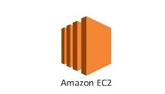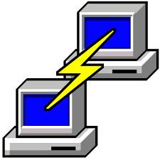

**Learning Outcomes**

* Launch an Amazon EC2 Instance
* Add a tag to an instance
* List instances
* Terminate instances

**Background**

This week we will continue to work with Amazon EC2 instances through the AWS CLI. Our focus will be on the creation and manipulation of instances. Please note: for this HOS, please use free tier eligible instances only.

**Resources**

https://docs.aws.amazon.com/cli/latest/userguide/cli-services-ec2-instances.html

**Step 1: Log onto your Amazon EC2 Instance**

Log onto your Amazon EC2 instance using either OpenSSH, Putty, or from the AWS Management Console using ‘EC2 Instance Connect’ (shown below). Note all IP addresses used in this series of Hands On Practice will be released by the time we start class.

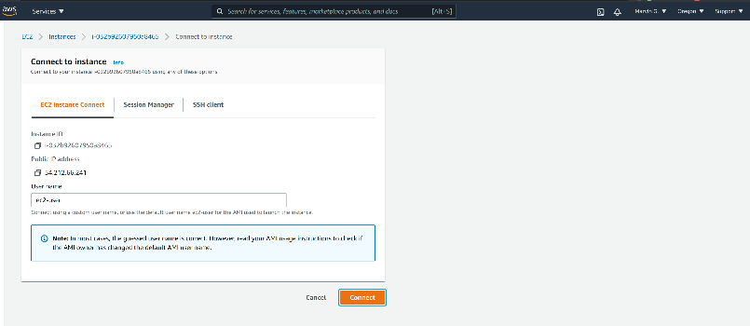

If you receive an error that you must first set your AWS Region and you must configure your AWS CLI, please follow these instructions.

<https://docs.aws.amazon.com/cli/latest/userguide/cli-configure-quickstart.html>  
  
Remember, do not use your root *account* for these operations. You should be using another IAM user. You should not have access keys to your root account.

**Step 2: Launch an Amazon EC2 instance**

We are going to launch an instance, please use the following ami : ami-0e472933a1395e172 (Amazon Linux 2)

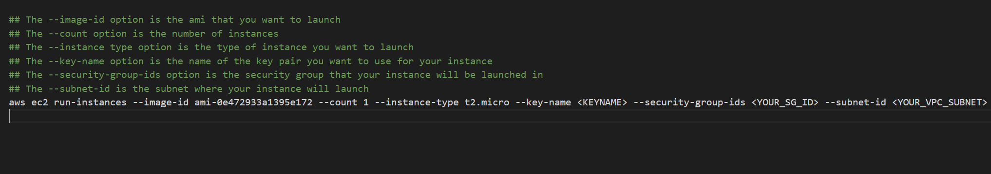

Now that your new instance is launched, lets see what instances we have available with the describe-instaces command.

**Step 3: List instances**

First, let’s take a look at what the “describe-instances” command can do.

On your Amazon EC2 Instance, type aws ec2 describe-instances help

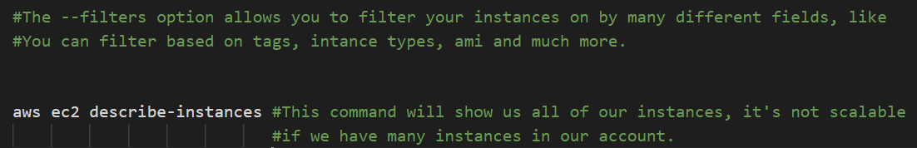

**Take a SCREENSHOT of your output.**  
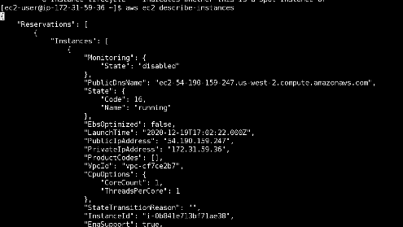

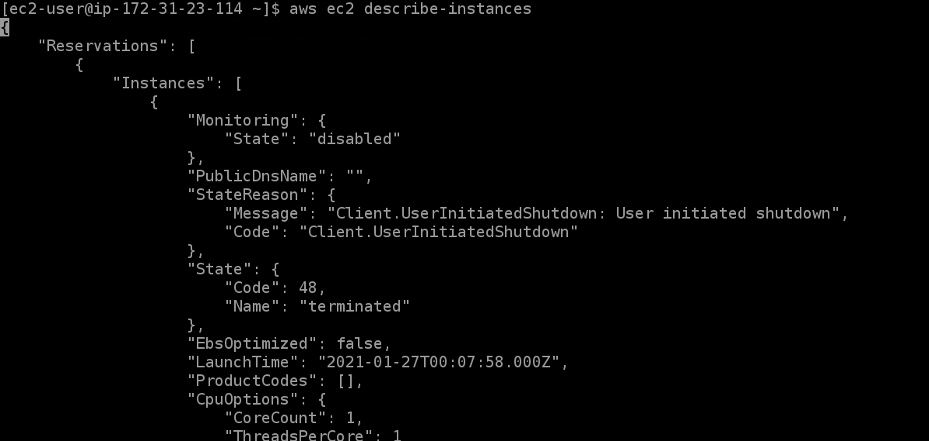

**Step 4: Terminating an Instance**

We no longer need the second T2.micro instance, let’s delete it.

First, look at the terminate-instances help to figure out all the ways we can delete instances.

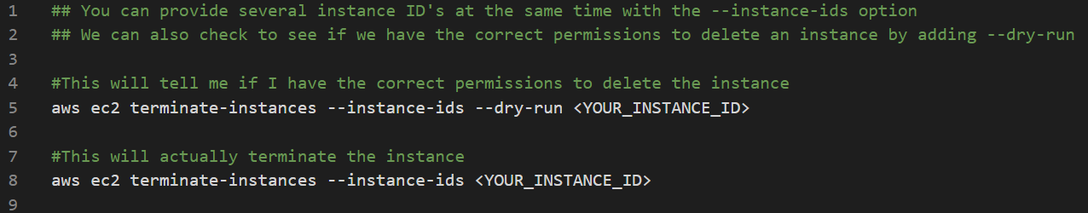

Your output should look like this in the CLI, and you can double check in the console.

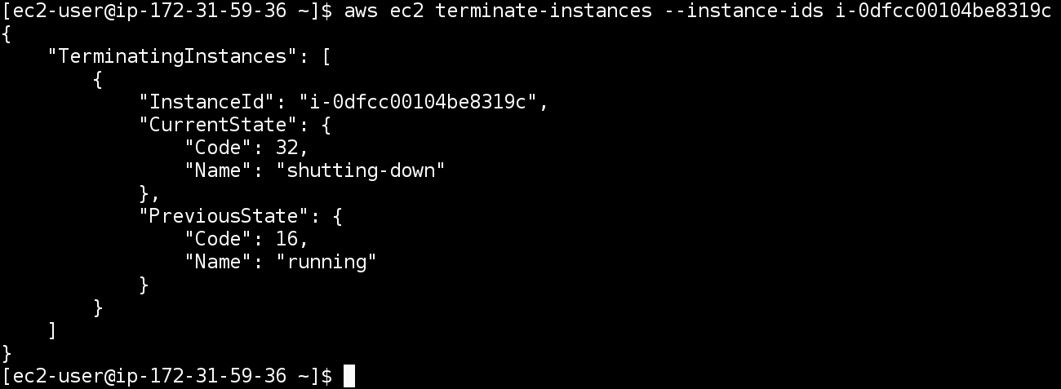

**Step 4: Tagging Instances**

Tagging is a very convenient way to label your AWS Resources. We can add tags to our Amazon EC2 Instance to name the instance, give the general function of the instance and much more. Tags are a **KEY:VALUE** pair.

Lets look at the create-tags manual aws ec2 create-tags help

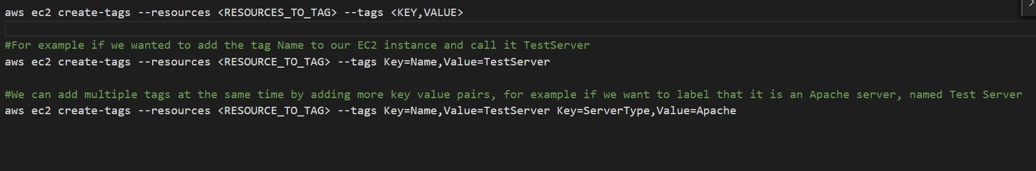

**Challenge 1:**

Perform the following on your Running EC2 instance

Add the following Tags to your EC2 Instance based on the description:

Your EC2 Instance is *named* DevelopmentInstance, it is part of the *stack* called Development, it is a *webserver* running Apache.

There should be three tags. Check in the console after you’ve added those tags to your instance.

**Take a SCREENSHOT of the output with the 3 tags.**

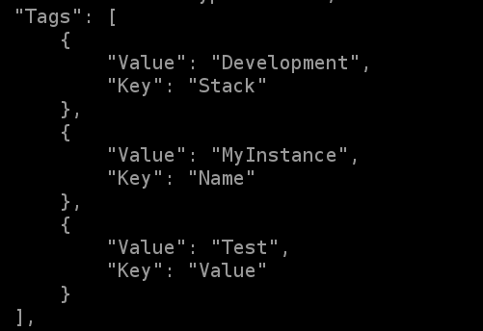

**Challenge 2:**Create a T2.Micro instance named ProductionInstance, it is part of the *stack* called Prod, that is running a *database* called MySQL.

Describe your instances and filter for apache instances.

Now describe your instances and filter for instances in the Production Stack and **TAKE A SCREENSHOT**

